NEW YEAR MARKET BOSWORTH EAST MIDLANDS
MOTORHOME SECTION 2023/24
We all arrived on Saturday afternoon [confusing as it’s normally a Friday], luckily it was all hard standing. In total 26 units and 46 attendees [ not inc. dogs] and three cancellations, what a turnout. Some braved the rain and wandered over to the club house to pay their fees and have a chat.
The evening was very jolly as we met up with old friends and made some lovely new ones. One couple came from Kingston on Thames, what a fluke and a bit of good luck for them. They were new to motorhoming and were on a site somewhere in the Cotswolds [I think] and met another couple in a pub who were booked on our rally, rang up and booked in. Being newbie’s they were not aware of rallies and were made very welcome and give a lot of advice over the weekend.
Sunday morning free and easy. Richard was spud bashing, even though he had done nothing wrong; yet!, the catering committee going shopping for supplies. In the afternoon tea/coffee, homemade cake and chat, later volunteers laying the tables for the festivities. Back to the vans for a rest and dressing up for the evening.
Diane and Linda etc had worked hard cooking and we were served sausage, mash, onion gravy, peas or beans followed by bread and butter pudding with custard or rice pudding with jam. Dave had set up the casino and we all had £15 to play with which could buy 30 chips. The blackjack and roulette tables were buzzing with the person at the end of the evening with the most money the winner. I suspected some insider dealing went on as Trevor had accumulate a large amount and was announced the winner.
It was nearly midnight and we all joined hands to sing Auld Lang Syne and let off party poppers with lots of kissing and jollity. The evening was over all too quickly and we headed back to our vans.
Monday, the sun shone for a while in the morning and some people went for a walk. In the afternoon Dave put a film show on the large screen, just like being at cinema with all round sound. It was called ‘The Bank of Dave’; I thought it was a made up title but actually a true life film. What a treat, the best film I’d seen in ages. During the interval, [too cold for ice cream] we had tea and more cakes, courtesy of Diane and Linda.
In the evening we met in hall for a gourmet spread of cheeses, crackers, bread, pickles etc. This was followed by a quiz and were entertained by the ‘TwoBs’, Jan and Ian for a good old sing song to which we could all join in.
Tuesday dawned and the rally was over too soon. Tea/coffee more cake and raffle which made £120 going toward hiring halls in the winter; and £10 raised from the cheese sale. Ian the Chairman thanked everyone for coming, especially all the people who mucked in and helped.
Lots of fond farewells and leaving a few pounds heavier after eating too much cake.
Big thanks to the Committee for running the weekend, especially the caterers Diane, Linda, all the helpers and volunteers for setting tables, washing up etc.etc. all help most welcomed
Another drive home in the rain, a theme of the whole rally, with some sunshine, but this did not dampen our fun and enjoyment.
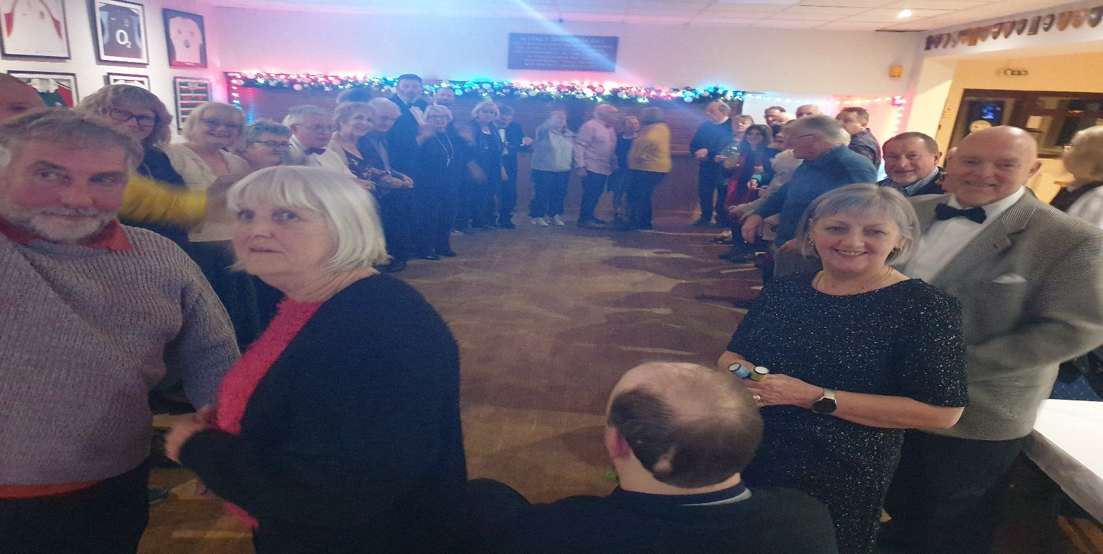

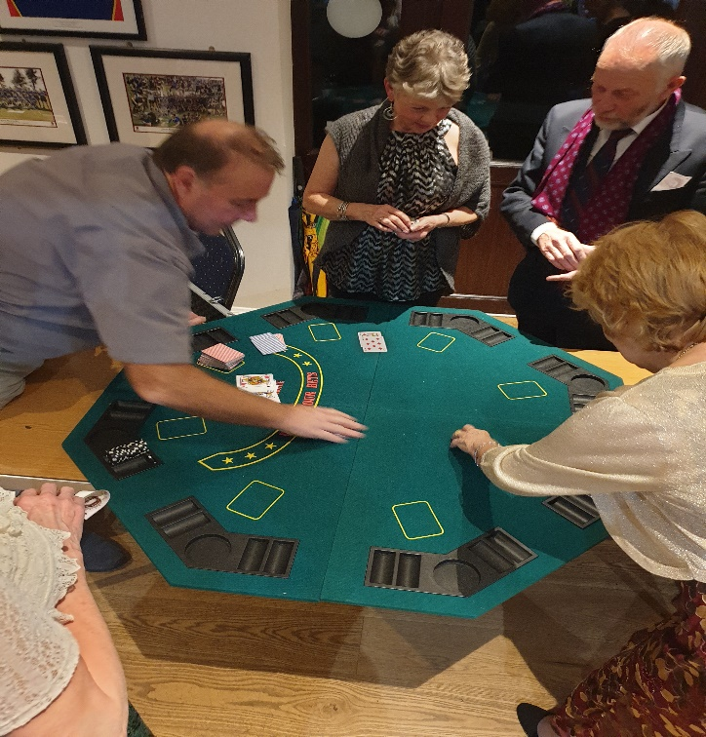
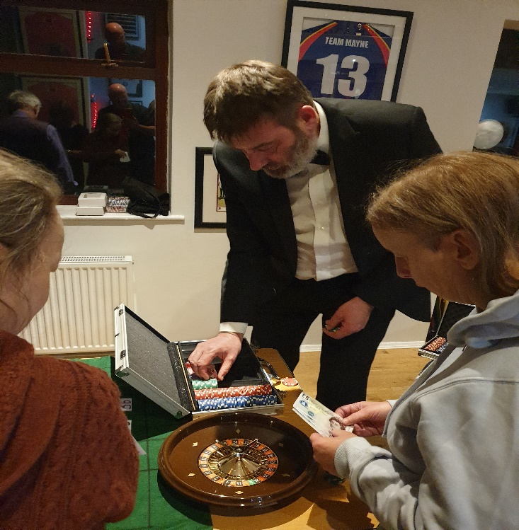

Maria & Richard

